­­­

Home Kitchen

Software Functional Specifications

Team Lead: Ayesha Tahreem Aamir 14L-4473

Members: Hafiza Ramzah Rehman 14L-4342

Mahnoor Fatima 14L-4293

Sana Fatima 14L-4079

Muhammad Bilal Zubairy

Date: 15th September 2017

National University of Computer and Emerging Sciences

Department of Computer Science

Lahore, Pakistan

Table of Contents

1.1 Purpose of this Document 3

1.2 Intended Audience 3

2. General Description 3

2.1 User Characteristics 3

2.2 Domain Overview 3

3. Functionality 4

3.1 Functional Requirements 4

3.2 Non-Functional Requirements 4

3.3 Assumptions 5

4. System Requirements 5

4.1 Hardware Requirements 5

4.2 Software Requirements 5

5. Prototype 6

5.1 Home Page 6

5.2 Post Food Item 6

5.3 Order an Item 7

5.4 Public Profile 8

5.5 My Food Orders 9

6. References 10

Introduction

The introduction of the **Software Functional Specification** provides an overview of the entire **website named HomeKitchen**. It includes the purpose, scope, audience, user characteristics, functional and non-functional requirements.

This project provides a platform i.e. a website for both cooks and buyers where buyers can see all food items available and can place order online. Moreover, they can see cook’s location so that they can estimate delivery/take away time. On the other hand, cooks can place their items. They can also see their orders in real time to faster the order process.

## Purpose of this Document

The purpose of HomeKitchen is to bridge the gap between the demand and supply of homemade food in big metropolitan cities like Lahore, Karachi and Islamabad, where lots of people move in for education or work, with no family to live with. Their only source of food is hotels and dhabas and are in a constant search of homemade food. Moreover, there are many women who want to earn some extra bucks with the skills that they are good at (cooking) but at the same time, they don’t have that much resources and logistics to start their own setup.

To abridge the aforementioned gap in society, HomeKitchen aims to provide free access to home-made, hygienic and fresh food through the responsive and interactive user interface. It will also focus on nonfunctional requirements like reliability, response time, maintainability and performance etc. All these factors will play a vital role in order to provide a complete and comprehensive description of the requirements for the software.

## Intended Audience

General skilled public who wants to earn money by showcasing their cooking foods i.e. sellers and those who want to eat home-made, hygienic and fresh food are the targeted audience. That is,

**Seller:** Seller will be the expert and skilled chef who will be earning money by showcasing his cooking skills.

**Buyer:** Buyer will pay for the hygienic and fresh food ordered.

Meanwhile, user can play role of both seller and buyer.

# General Description

## User Characteristics

* User(s) understands basic English language.
* User(s) knows how to type on keyboard or keypad.
* Seller(s) knows how to take and attach images.
* User(s) is familiar with website usage.
* User(s) have a know-how about the working of e-commerce website.

## Domain Overview

Home Kitchen is an online web application where expert cooks sell their home-made food items and foodies place orders to buy those items. Foodies can then review or rate the food item, he bought from the cook. Furthermore, we will be using MVP model for our system.

# Functionality

## Functional Requirements

Below are the functional requirements of HomeKitchen website:

* System shall provide login and sign up functionality to both buyers and sellers.
* Seller(s) posts food items by adding food name, picture, price, description and food available timings.
* Buyer(s) places orders by choosing a food item and providing the delivery address. Seller(s) will receive a notification about the order placed and will confirm it.
* User(s) views the history of previously bought and sold food orders placed as well as upcoming bought and sold food orders placed.
* User(s) maintains a profile that is visible to all other users using the web application. This includes basic personal information such as profile picture, username, rating, reviews and much more.
* User(s) views and modify their own profile details such as email address, phone no., profile picture and home-address etc.
* User(s) who buy online food rate (on a scale of 1-5) and review the cook on the basis of quality of food delivered to him.

## Non-Functional Requirements

We have taken the assumption that server handles 10,000 people at maximum and responds best at peak hours accordingly.

* System shall be easier to use such that user can place the order in maximum 3 steps as the user(s) knows basic English and have a know-how of website usage.
* System shall contain 3 to 4 help frames to guide the user(s) when he gets stuck somewhere.
* System shall be reliable at rush hours that is 8:00 am - 3:00 am a day. Down time should not exceed 15 minutes during these hours.
* At most, 10,000 users can hit the server without facing any failure.
* Between 3:00 am-8:00 am a day, down time should not exceed 20 minutes.
* System recovery time should not exceed
  + 30 minutes in case of minor failure.
  + 3 hours if major functionality fails.
  + 1 day if system crashes.
* Failure rate of the system shall not exceed 2: 10,000.
* For any request, response time of system shall not exceed 2 seconds.
* Searching through a large number of items/dishes should be fast and rendering should not take more than 5 seconds.
* HomeKitchen is functionally operate-able from various browsers such as Google Chrome, Edge, Firefox etc.

## Assumptions

* Server handles 10,000 people at maximum and responds best at peak hours accordingly.
* Buyers and sellers negotiates either order is home-delivered or taken away.
* The system does not cater any payment as of yet. Buyer, seller and business owners of HomeKitchen will deal with it.

# System Requirements

The hardware and software requirements that will be required to develop and deploy the HomeKitchen are as:

## Hardware Requirements

* Online cloud server
* Database server

## Software Requirements

* JustInMind (for wireframing)
* IntelliJ Idea
* Adobe Photoshop
* Apache Tomcat Web Server
* SQL Server Management Studio

# Prototype

## Home Page

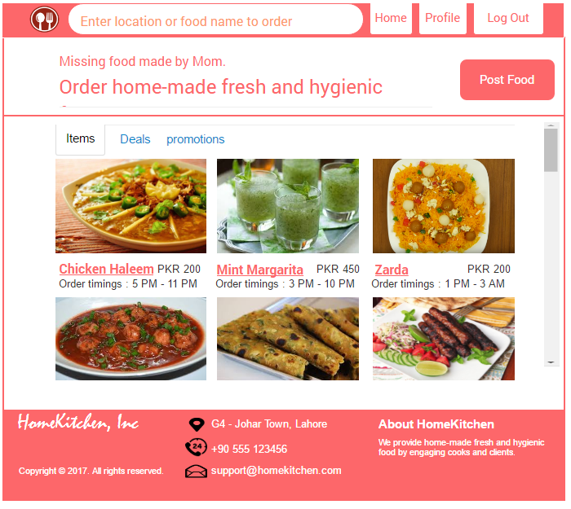

## Post Food Item

When Post Food button from home page clicked, then a pop-up will appear.

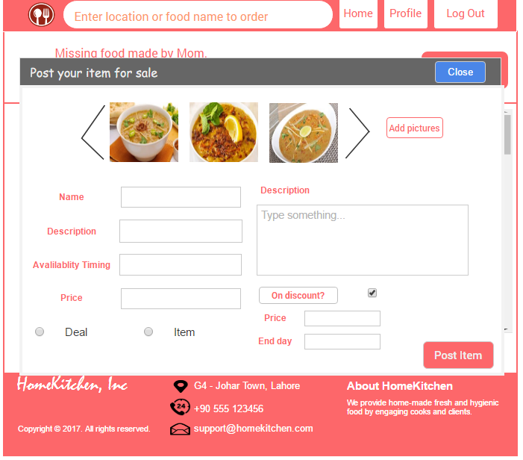

## Order an Item

When any item from home page selected.

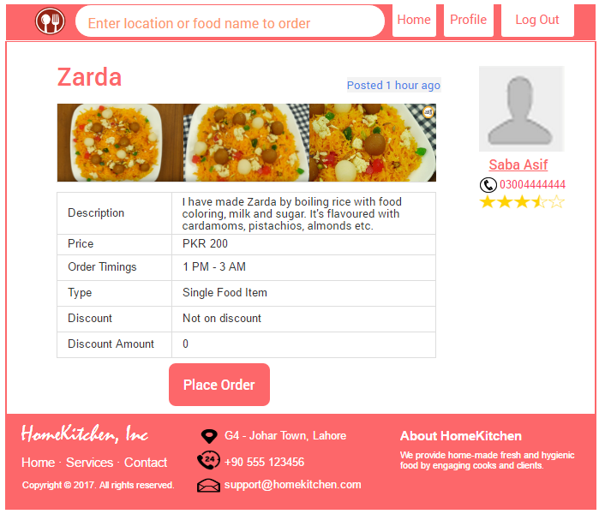

## Public Profile

When profile from top navigation bar clicked.

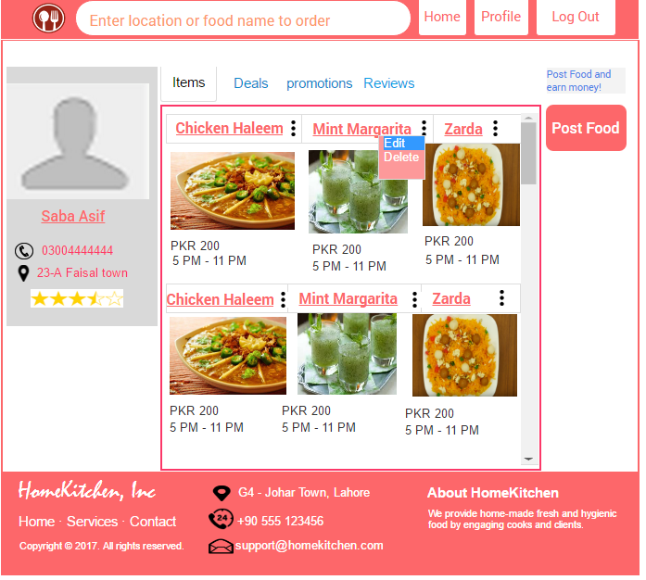

## My Food Orders

Record of current and previous bought and sold orders.

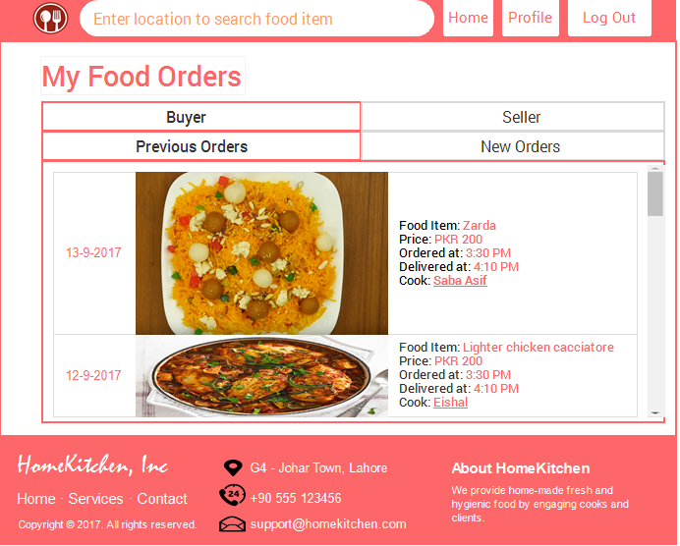

# References

* <http://www.lunch.pk/>
* <http://fooddiaries.pk/rabias-kitchenette-delivering-excellent-home-cooked-food-lahore/>
* <https://www.foodpanda.pk>